**Project title: “MyPyShell”**

**Project description:**

Our project is a combination of 2 major functionalities i.e.

1. **Command line interpreter or Shell**
2. **Text Editor**

**List of team members:**

**Swayanshu shanti Pragnya**

[**Hemantharaj Raguraman**](https://ucdenver.instructure.com/courses/415282/users/312253)

**Subash Shankar**

**Jingsheng Li**

**Project**

1. **My Py text editor**

**Functionalities**

* **New**

This feature provided us to create a new file.

* **Open**

In this function we can open the existing file.

* **Save**

Word saves the document in a default location. To save the document in a different location, select another folder or location.

* **Save as**

Word saves the document in a default location. To save the document in a different location, select another folder or location.

* **Copy**

When you press "Control-C" or click the "Copy" copies the selected text into the clipboard. The text also remains in its original location.

* **Paste**

When you paste text, the computer does not remove it from the clipboard, so you can paste it multiple times or in several places without needing to copy it again.

* **Cut**

The "Cut" function removes the currently selected text and places it on the clipboard. The clipboard on a computer functions as temporary storage for the last item you've cut or copied.

* **Select All**

This feature provide us the functionality to select all the text.

* **Undo**

This feature provide functionality to undo the action in the text editor.

* **Redo**

This feature provide functionality to redo the action in the text editor.

* **Exit**

This feature provide functionality to exit from the text editor.

* **Find**

 Word can automatically search your document using the **Find** feature.

* **Font**

A font is the combination of typeface and other qualities, such as size, pitch, and spacing. For example, Times Roman is a typeface that defines the shape of each character. Within Times Roman, however, there are many fonts to choose from -- different sizes, italic, bold, and so on.

* **Print**

This feature provide the functionality to print the any document or the text written in the text editor.

* **Misspelled Highlight**

This feature provide the functionality to highlight the misspelled word or wrong spelled word written in the text editor.

* **Calculator**

(for basic calculation like multiplication, division, addition, subtraction)

* **TECHNICAL REQUIREMENTS**

***Technologies Used***

**Frontend language**: Python, tkinter and wxpython

**Frontend tool:** Jupyter notebook

**Operating System:** Linux, and Windows

**Backend tool:** Command Prompt, Terminal

As per the project proposal we started with few basic functionality for a notepad which includes

1. **Creating new file**
2. **Save and save as (different file format)**
3. **Close any particular file**
4. **Exit**
5. **Opening any file from any drive present in the system**

These are the following snapshots of our Initial code-

1. **File --- > New**

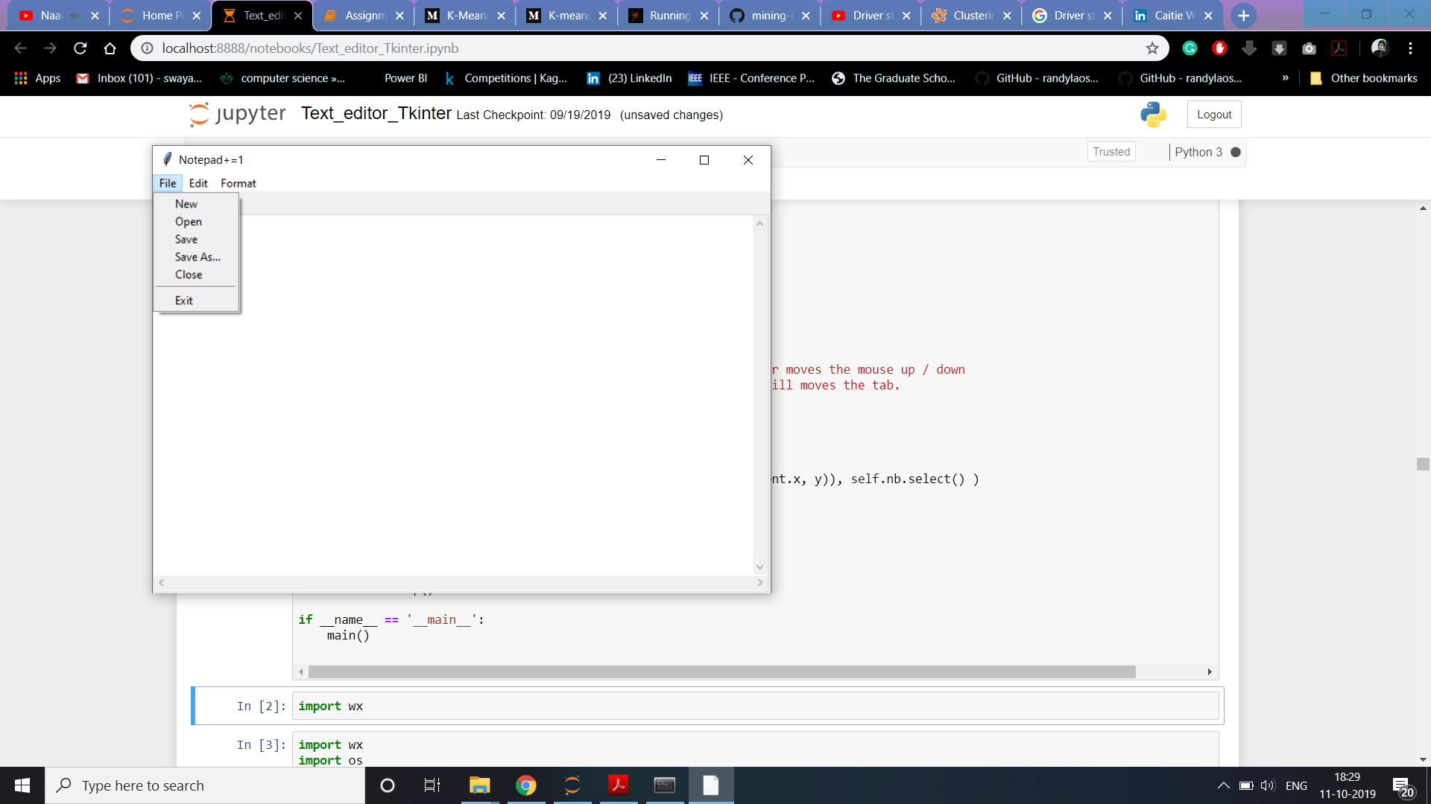

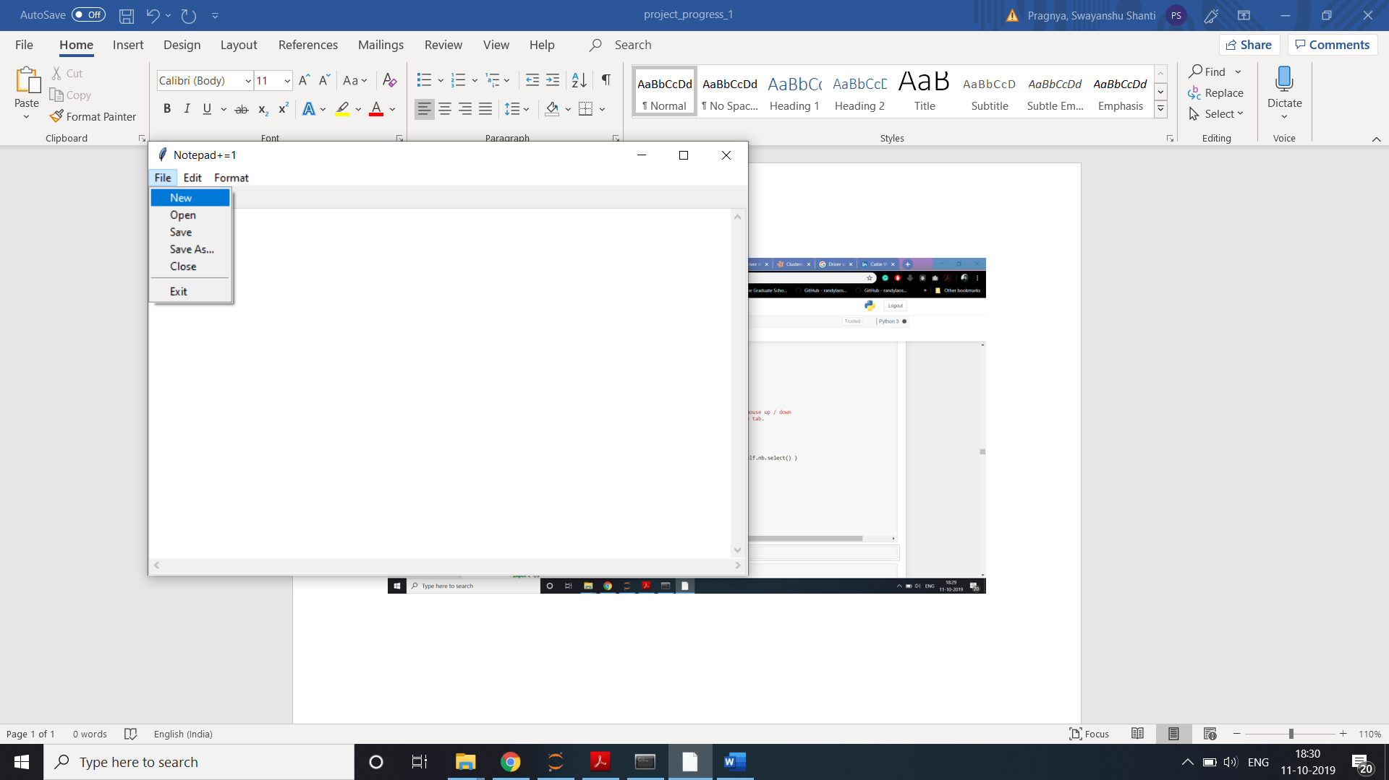

**Here 1 untitled File is opened.**

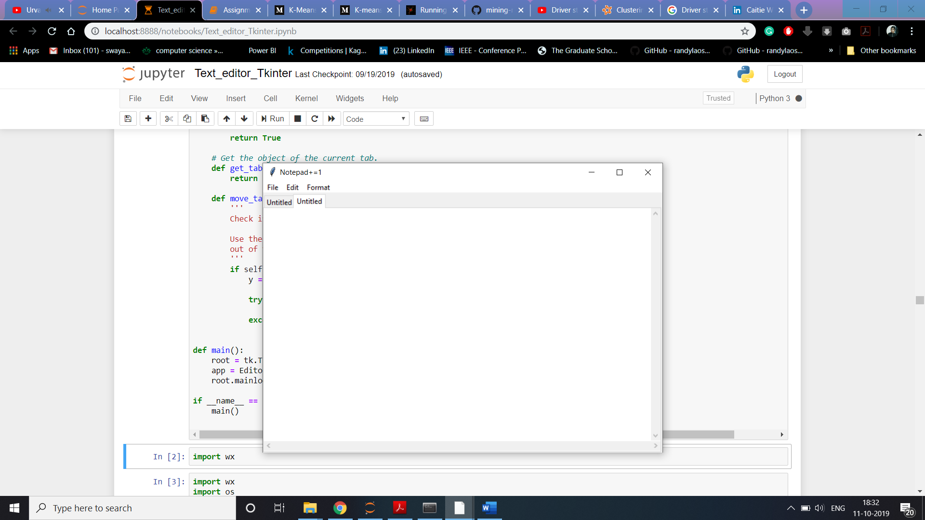

1. To save the file in different file format we can use File -🡪 Save As

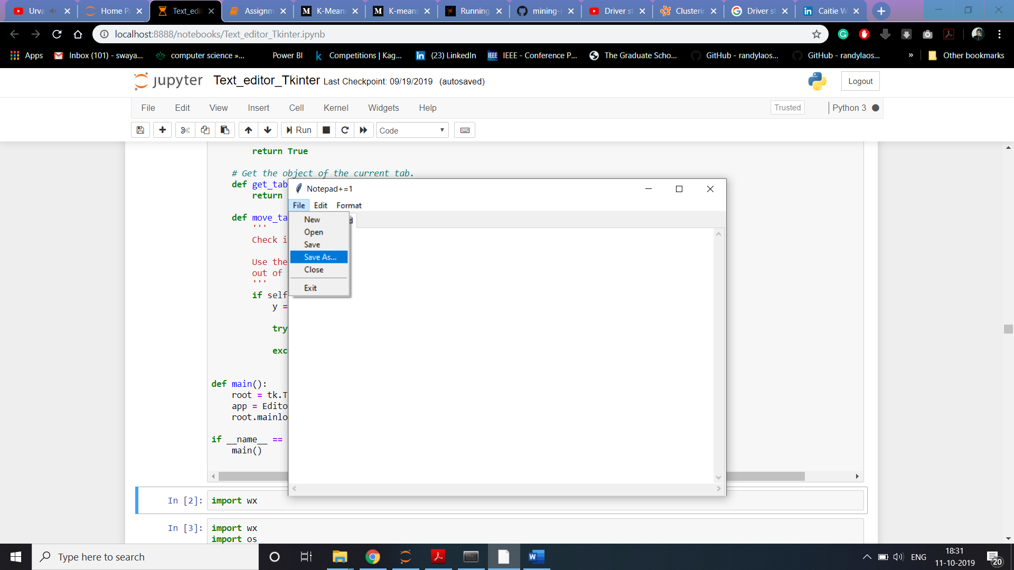

Here the file format is selected to All files

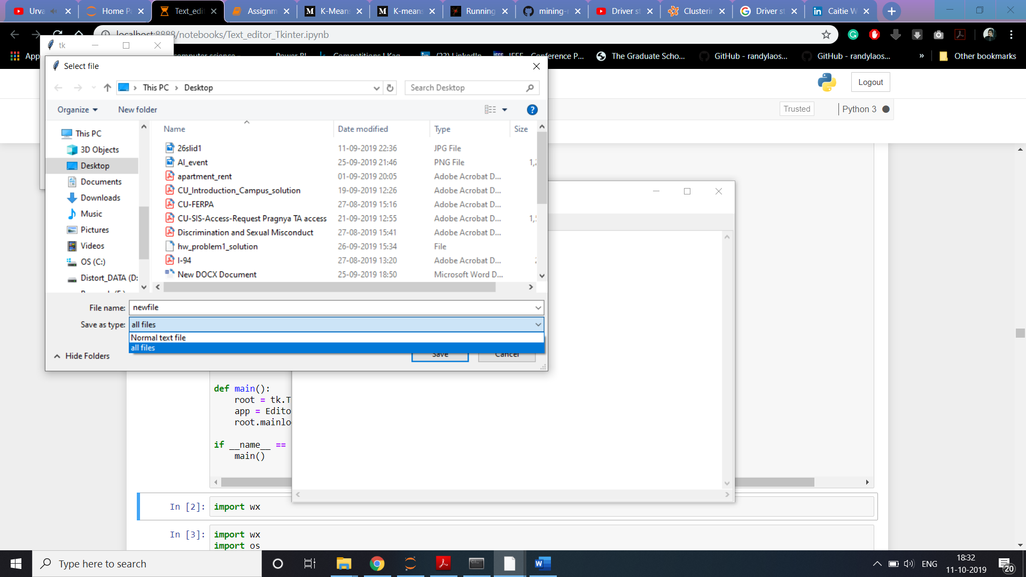

1. Open a new or existing file from drive

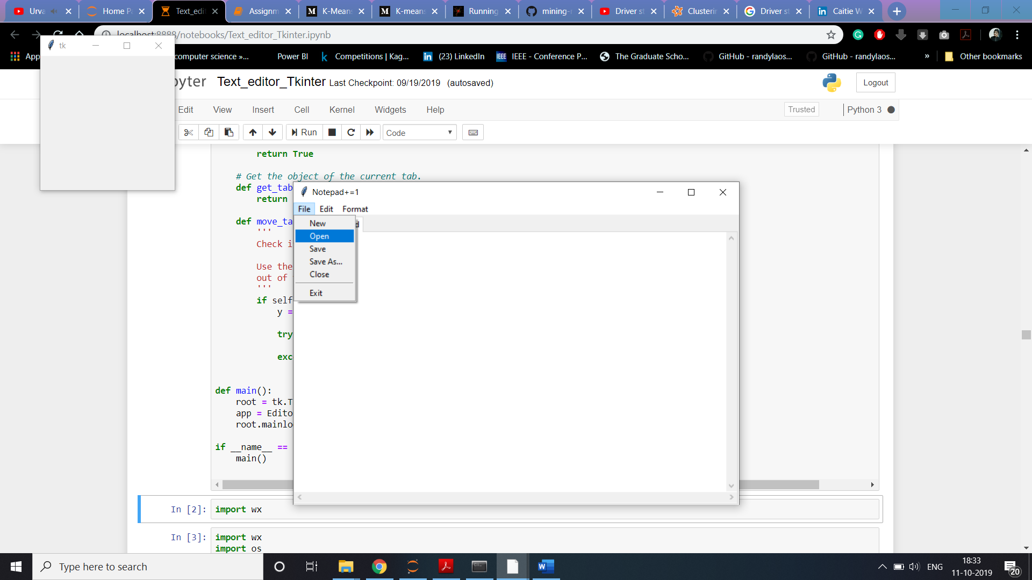

Selected a File from desktop named as spark_wordcount.txt

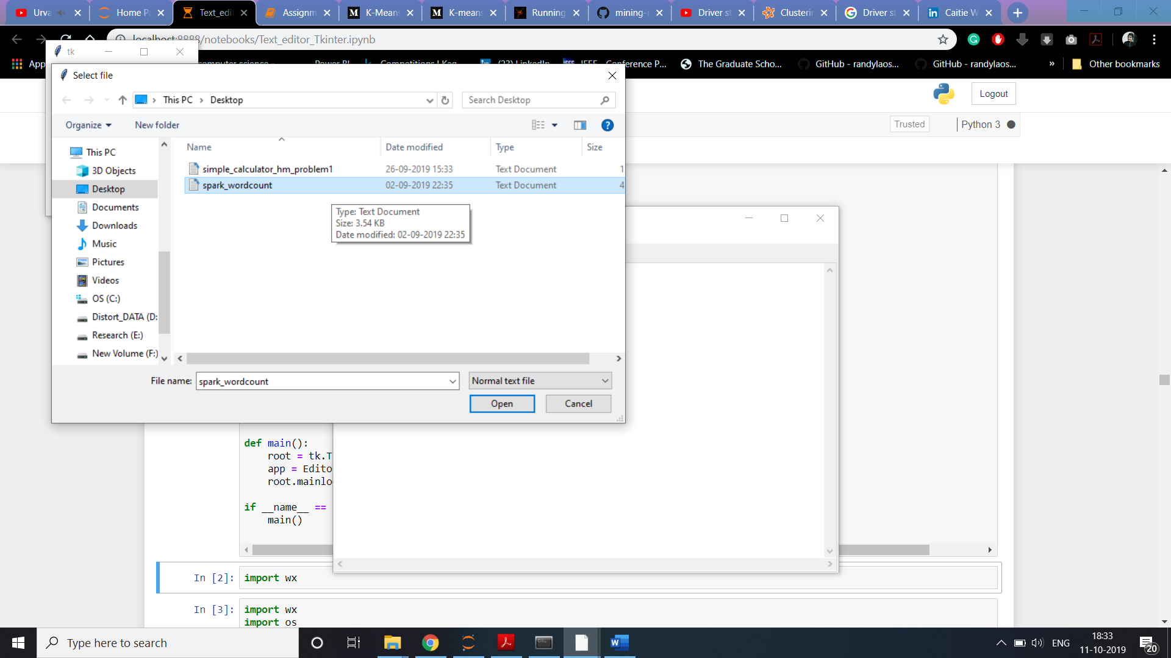

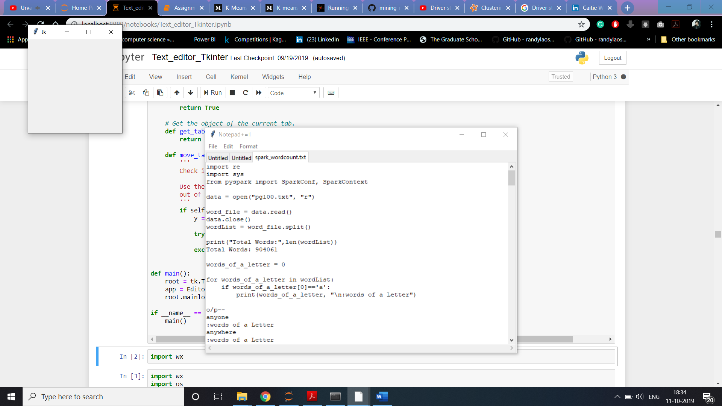

1. Select all the text from a file

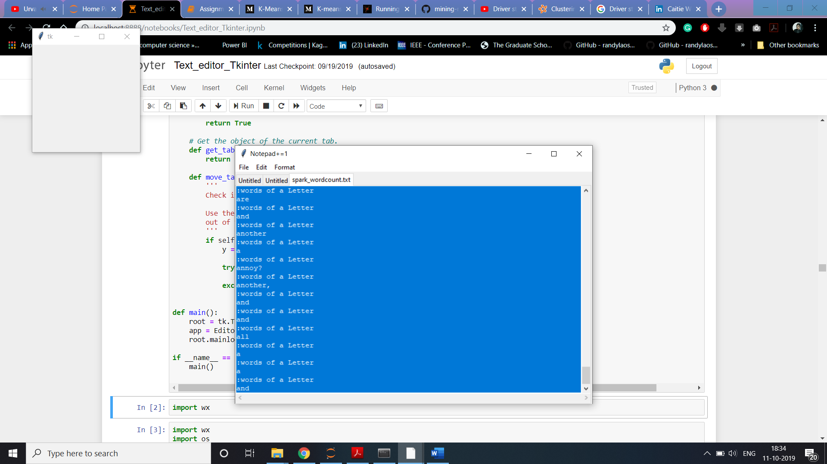

1. **Exit**

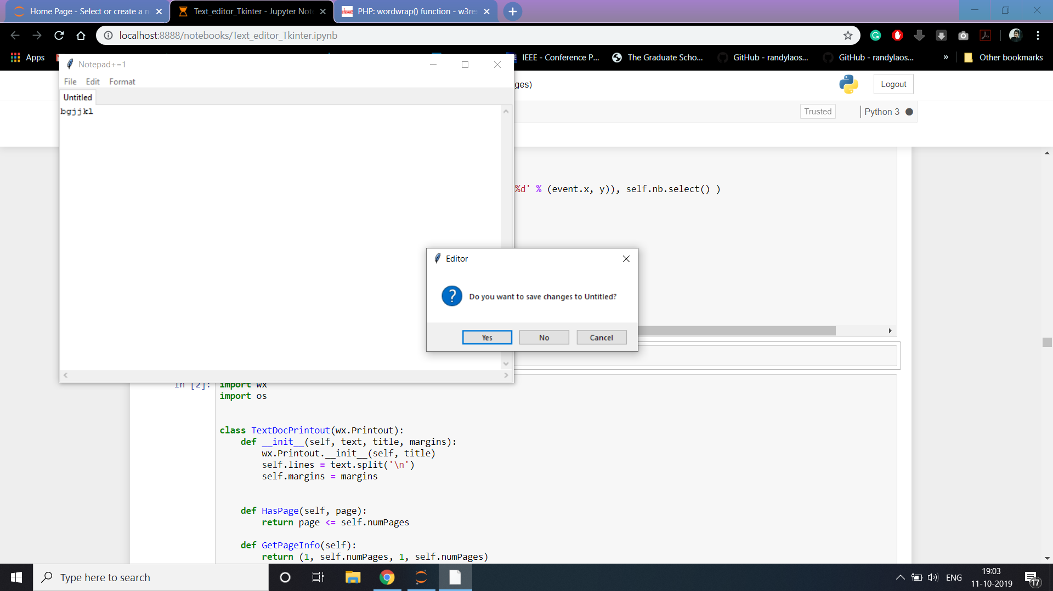

**Error:**

1. While implementing such application 2 files are opening by default which we will try to solve.

**Future work:**

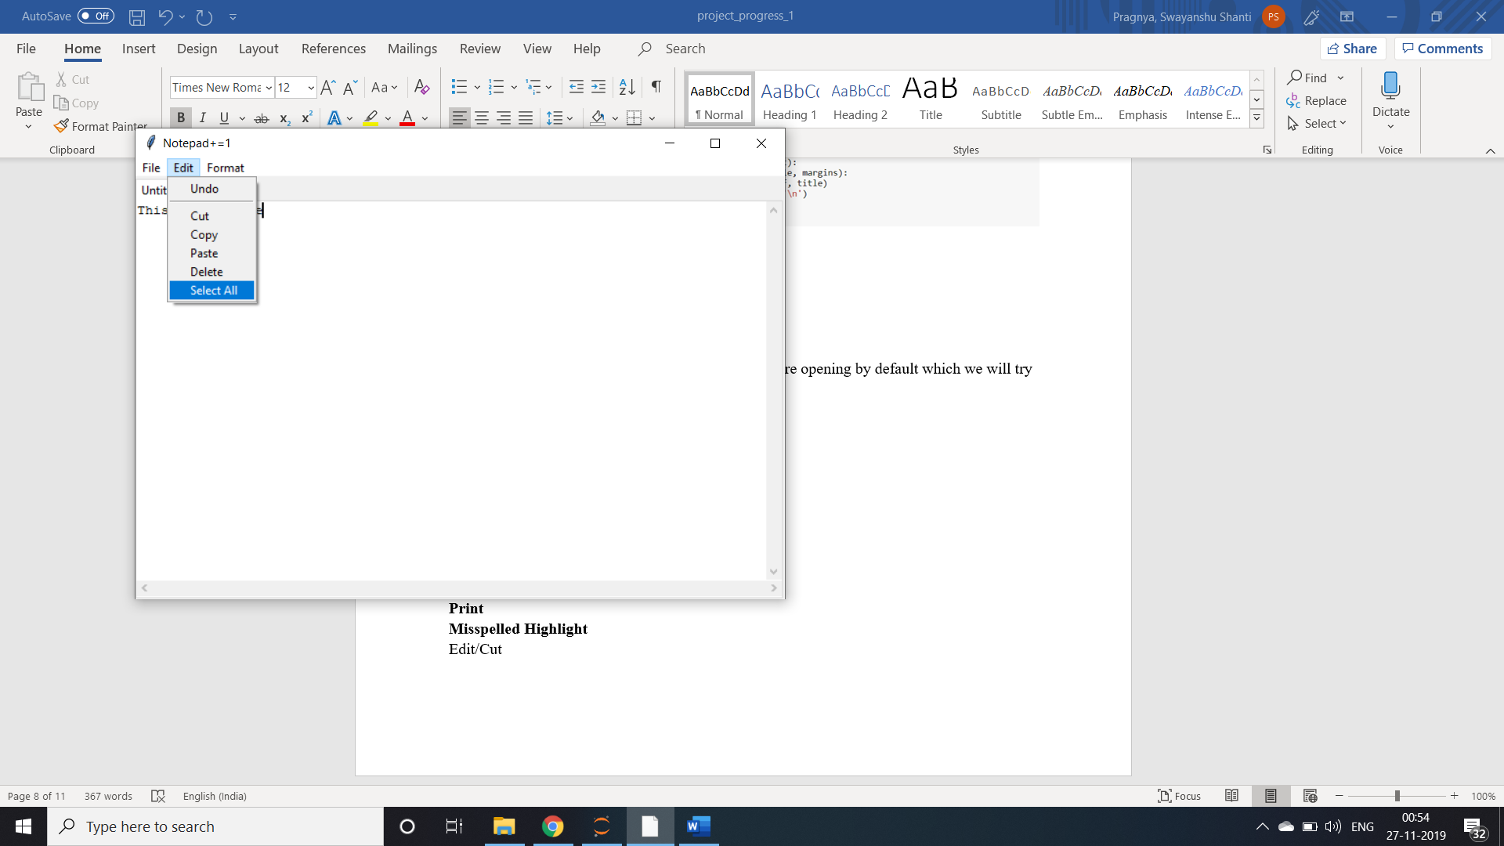

**Functionalities like:**

**Font**

* **Change Font**

In this functionality user can change the font of the text.

Go to View > Font.

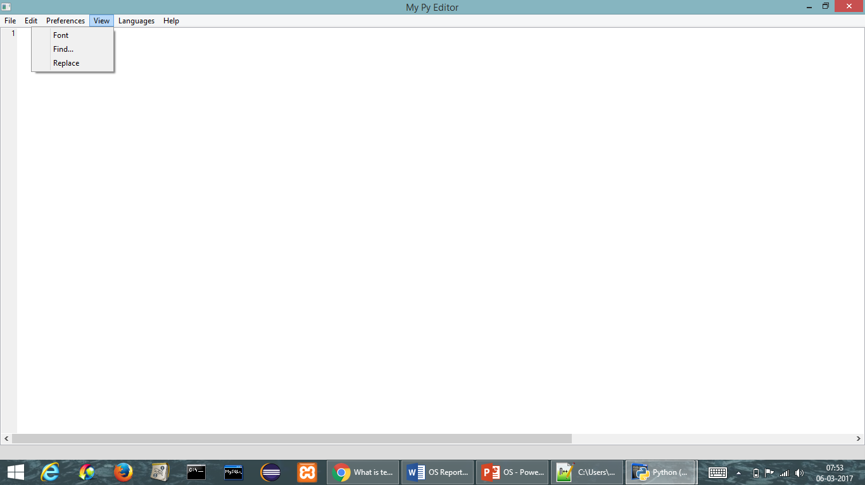

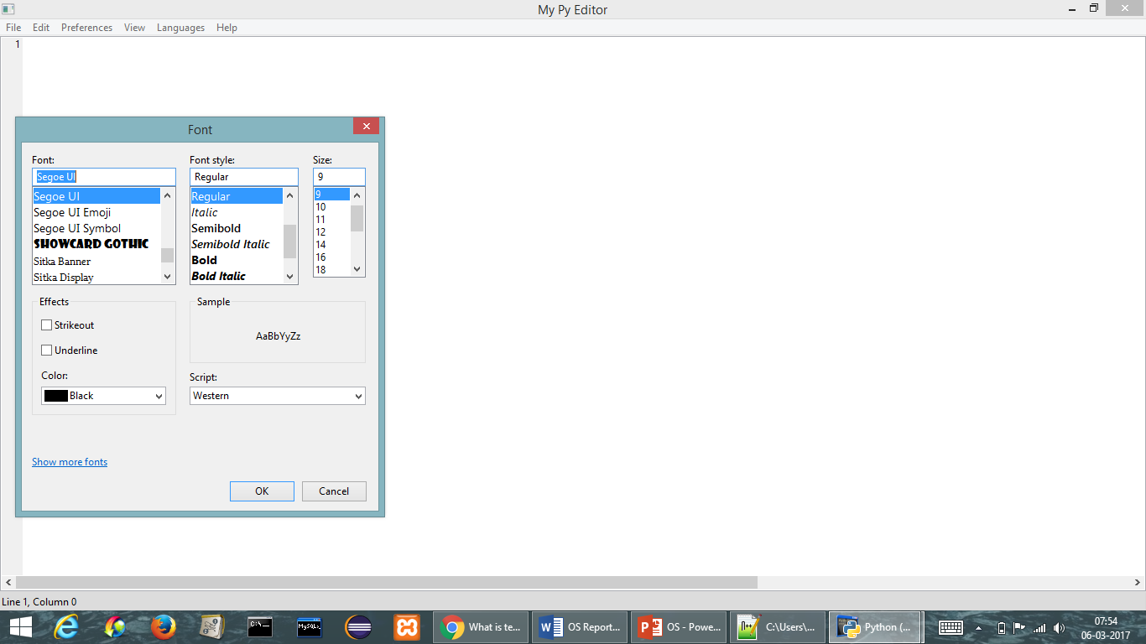

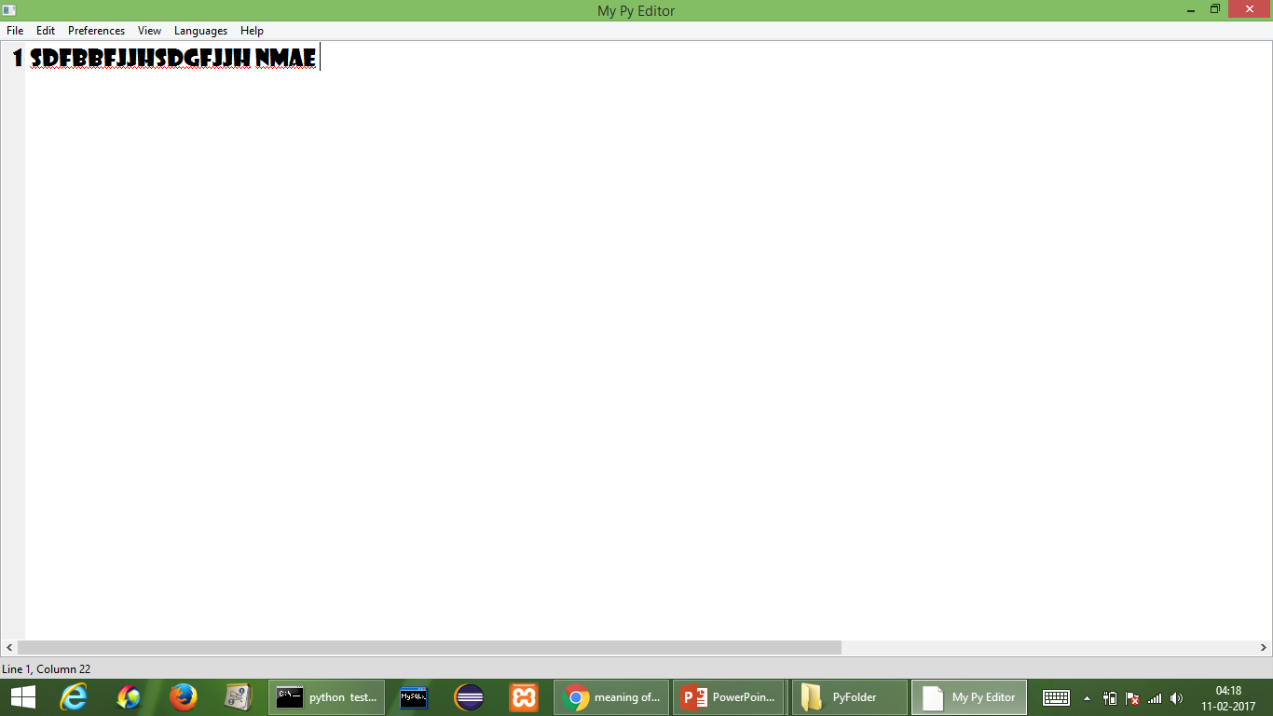

**Print:**

* **Print File**

In this functionality user can print the file.

Go to File > Page Setup (Page Setup) then > Print.

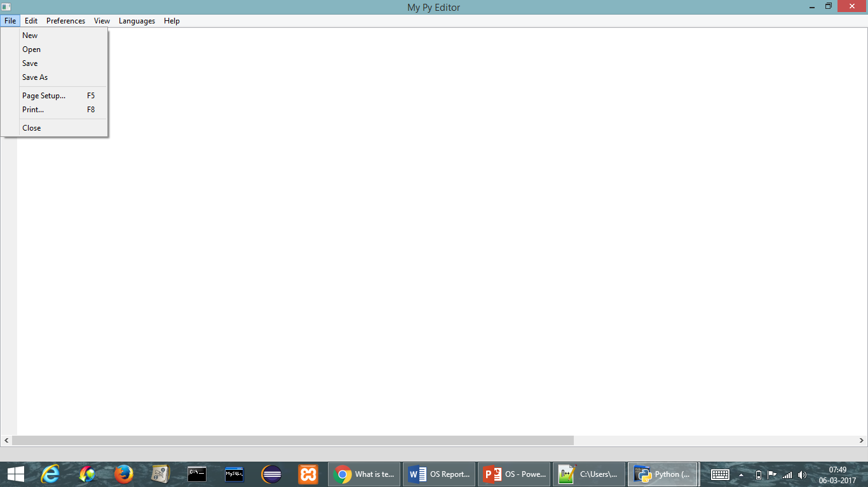

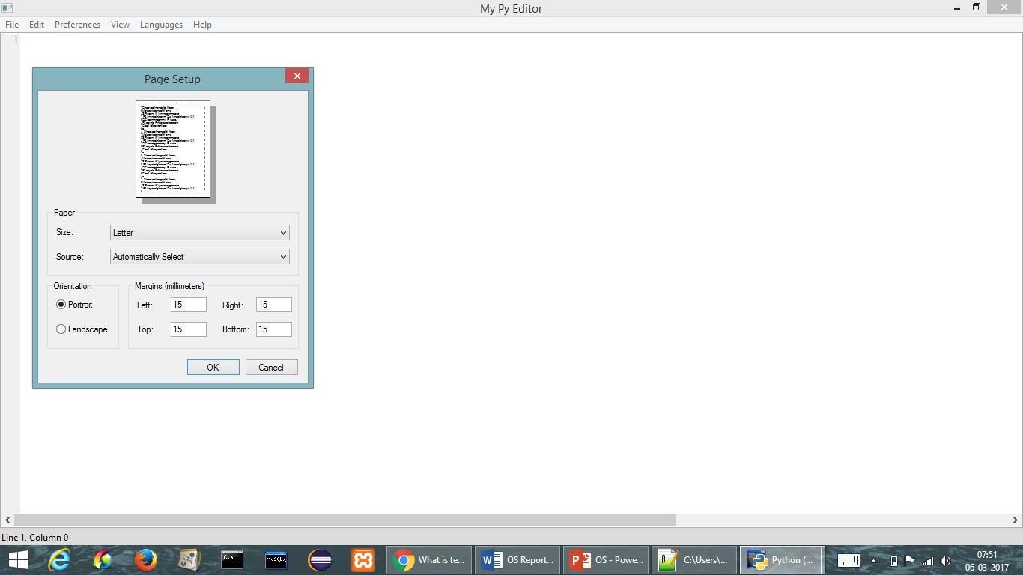

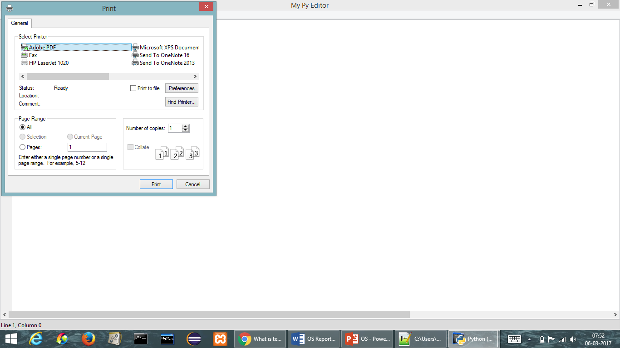

**Misspelled Highlight**

Edit/Cut

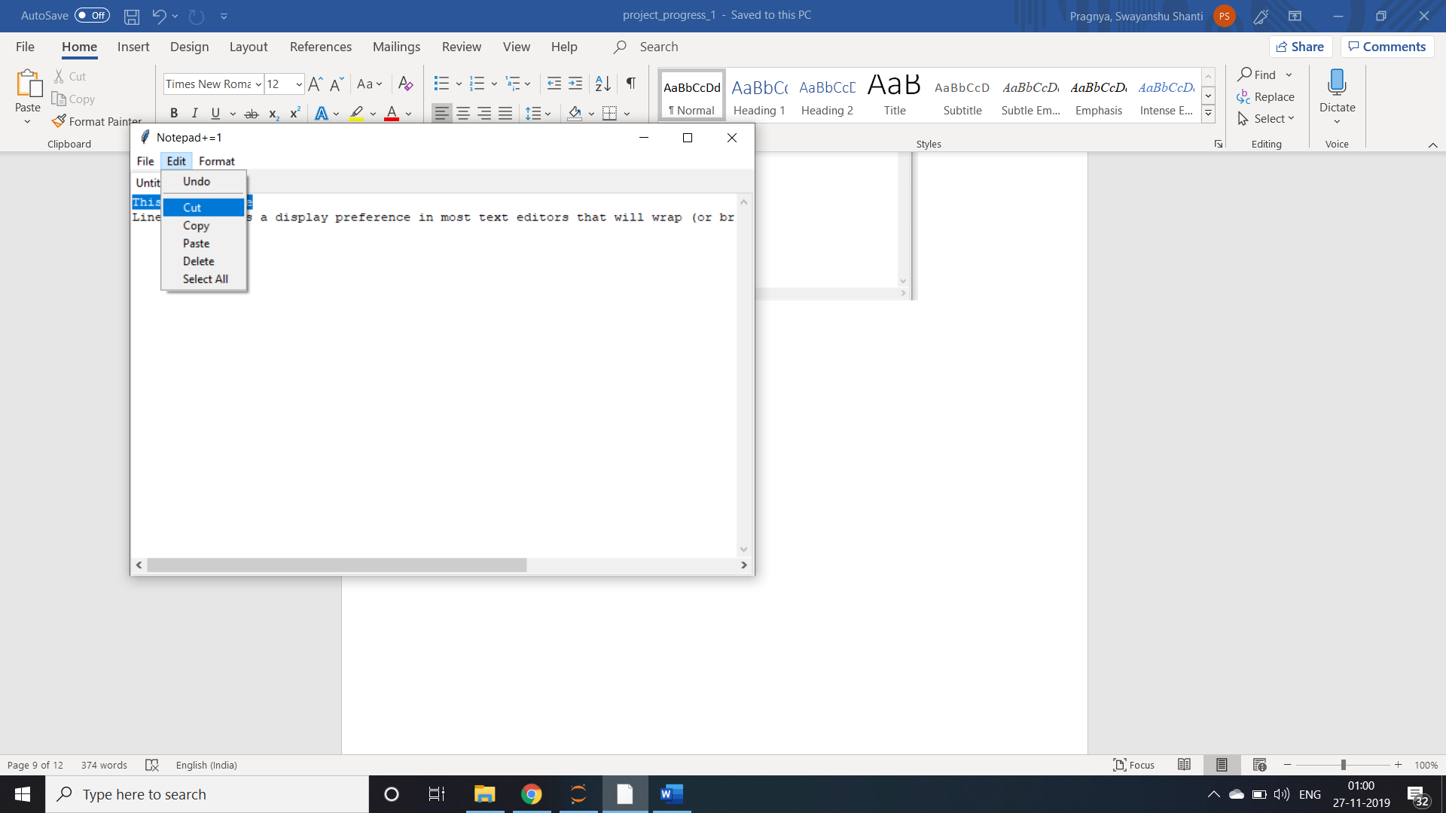

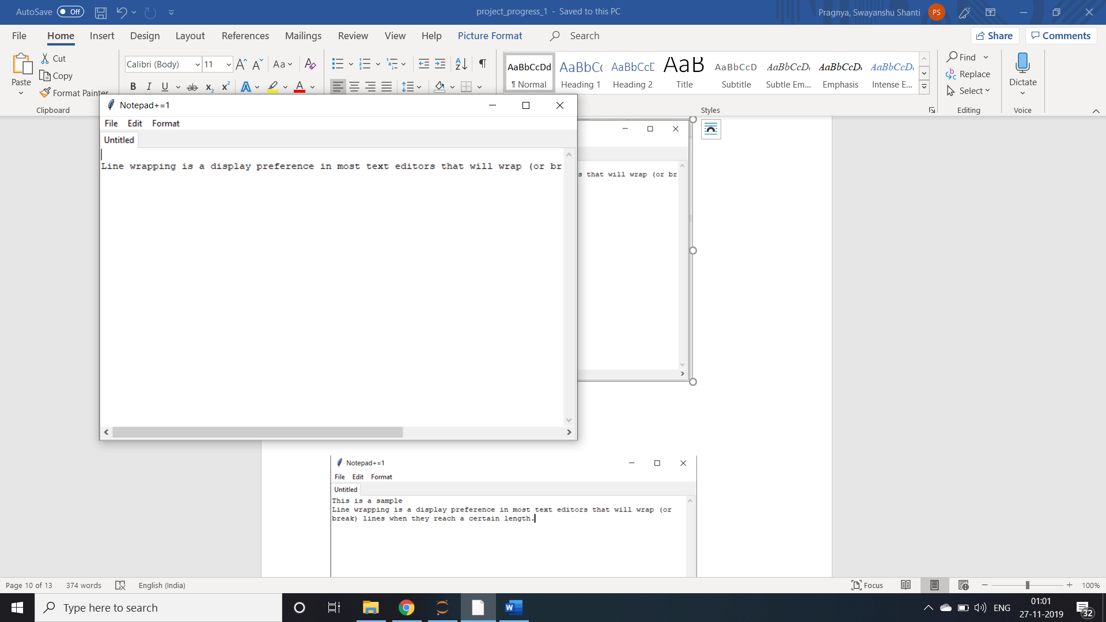

Paste:

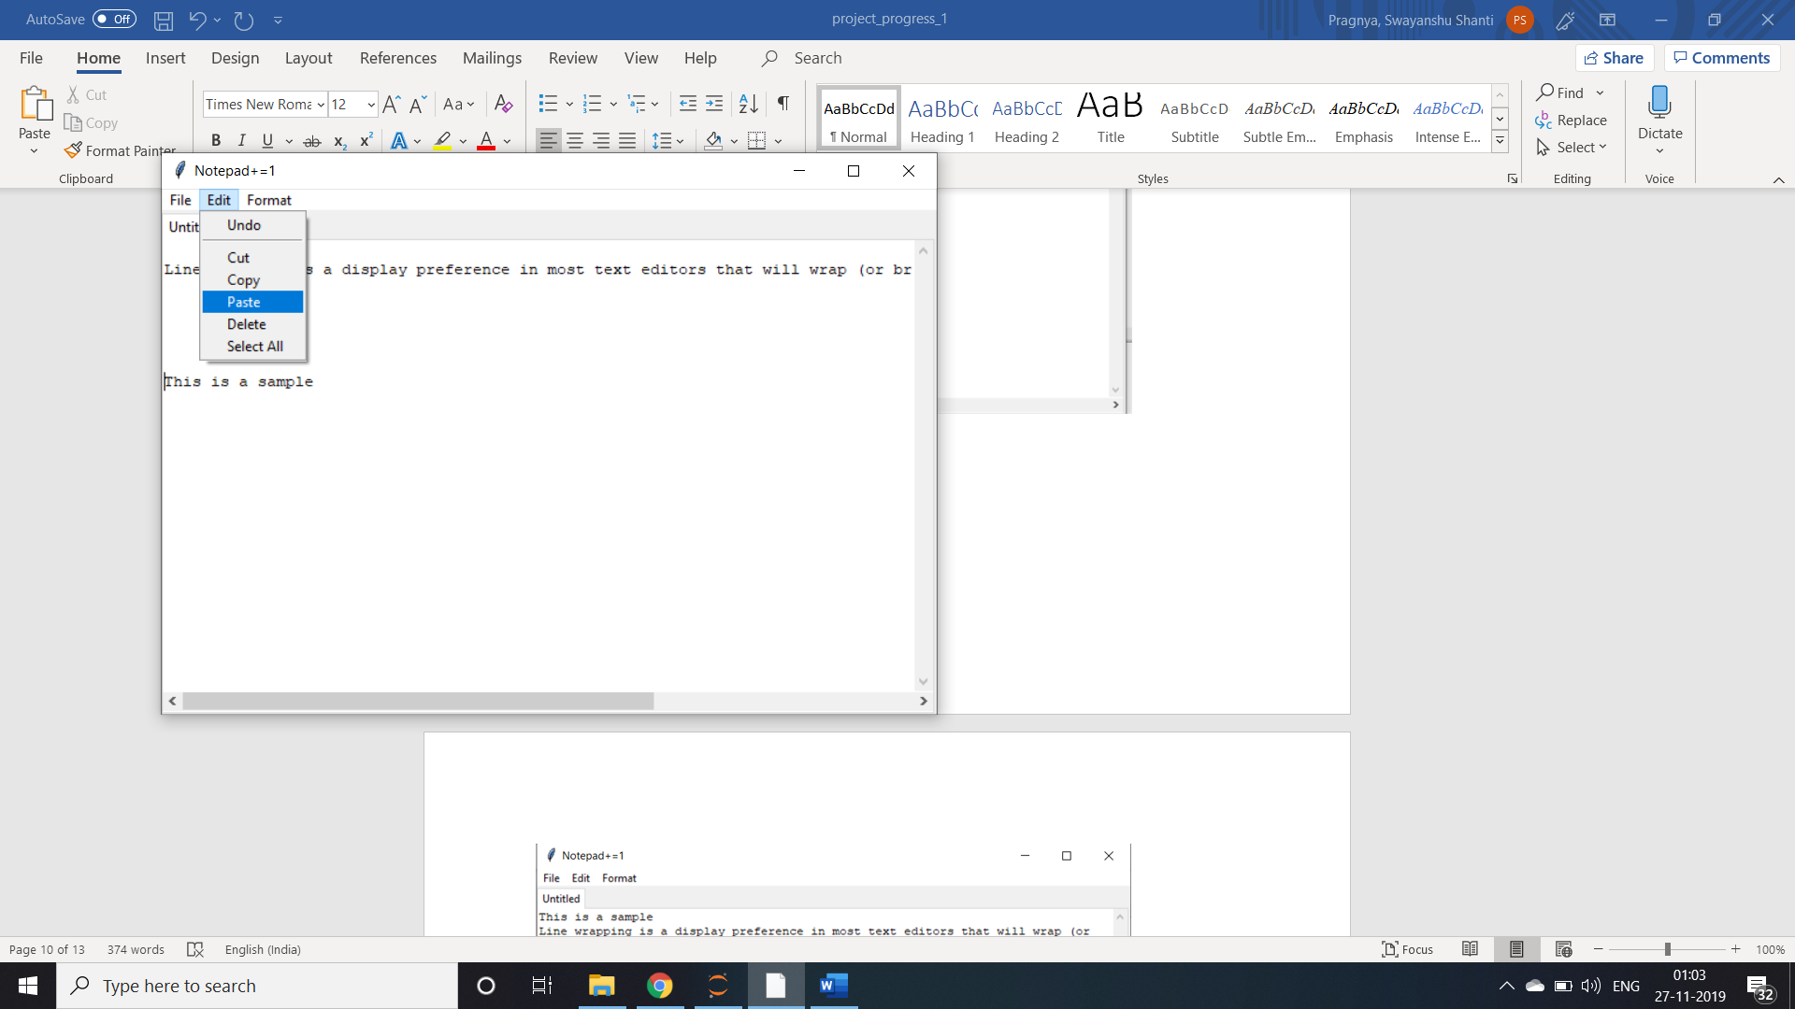

Word wrap:

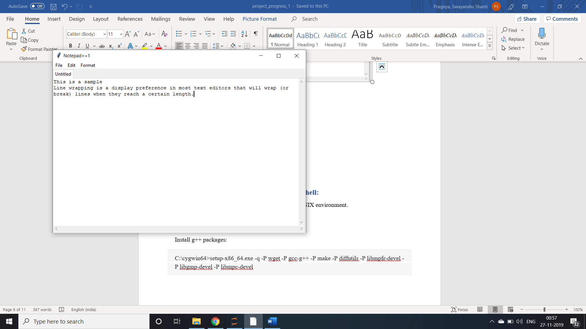

After using word wrap the o/p is-

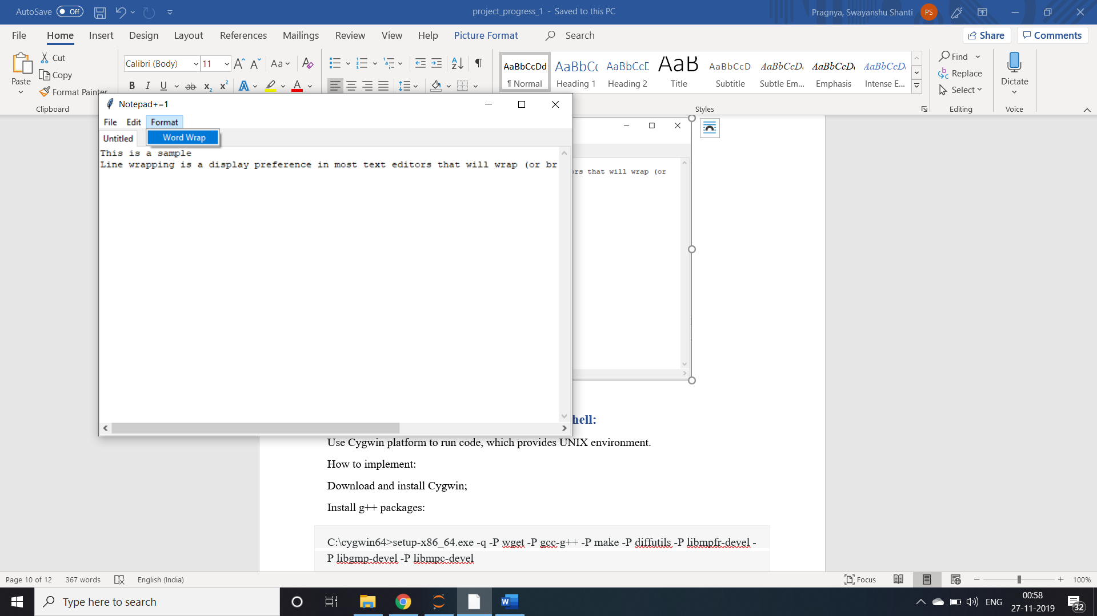

Calculator with Notepad

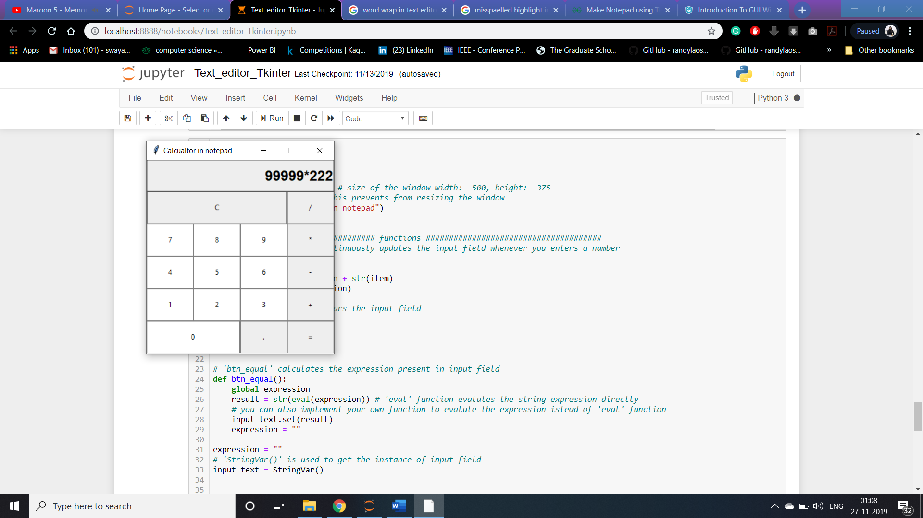

1. **Build a shell:**

Use Cygwin platform to run code, which provides UNIX environment.

How to implement:

Download and install Cygwin;

Install g++ packages:

C:\cygwin64>setup-x86_64.exe -q -P wget -P gcc-g++ -P make -P diffutils -P libmpfr-devel -P libgmp-devel -P libmpc-devel

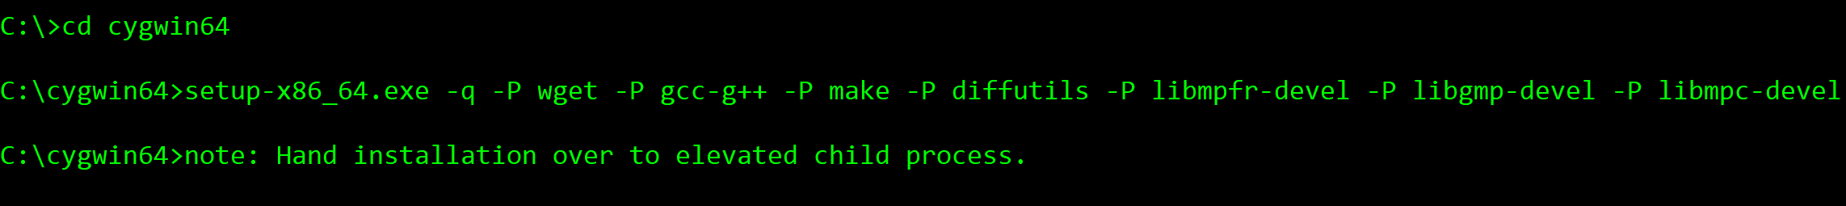

$ wget http://ftpmirror.gnu.org/gcc/gcc-4.9.2/gcc-4.9.2.tar.gz

$ tar xf gcc-4.9.2.tar.gz

$ mkdir build-gcc

$ cd build-gcc

$ ../gcc-4.9.2/configure --program-suffix=-4.9.2 --enable-languages=c,c++ --disable-bootstrap --disable-shared

$ make -j4

$ make install

$ cd ..







And test using hello.cpp file

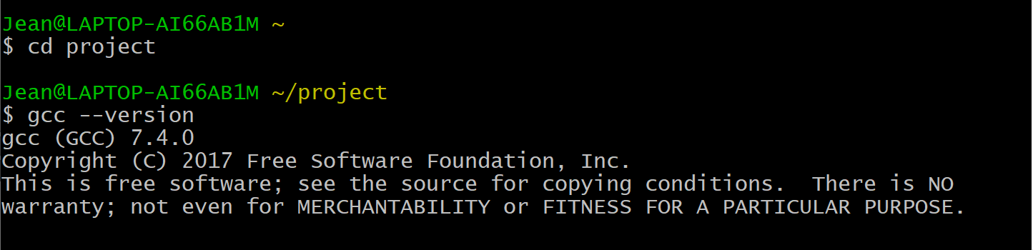

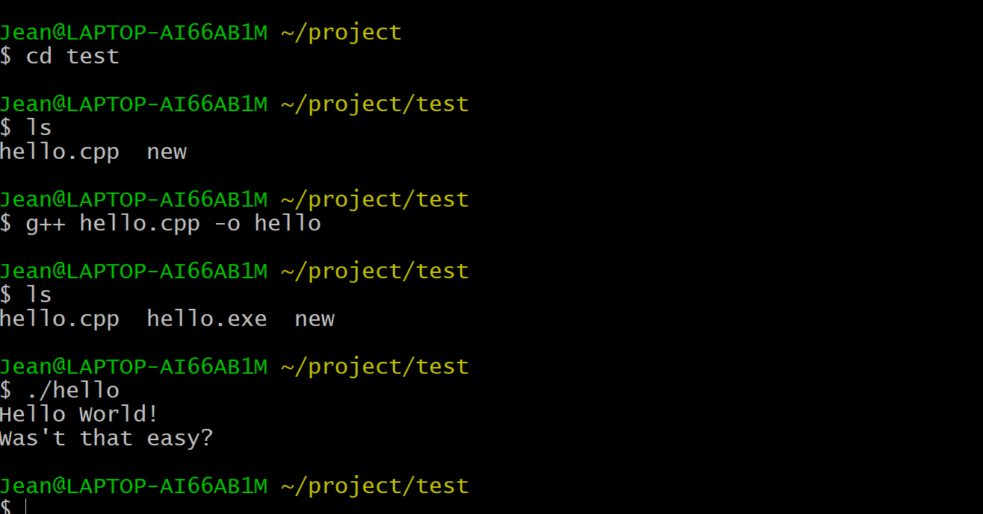

It runs successfully

A shell includes three main things.

Initialize: a shell can read and execute its configuration files.

Interpret: the shell reads commands from stdin.

Terminate: the shell executes any shutdown commands, frees up any memory, and terminates. -->exit command

First: build a simple shell just call the looping function and terminate.

already installed gcc complier successfully and tested with a cpp file in Cygwin64

After that, wrote down three basic functions of the shell.

In future, we need a complete cpp file for the shell, and we need add some functionalities to the shell.